UJIAN AKHIR SEMESTER GANJIL TAHUN 2021/2022
Mata Kuliah | : Jaringan Komunikasi Data
Waktu | : 30 menit
Kelas | : 3A/B

NAMA : RENA TASYA SHAFIRA NIM : 191331061
- Protokol mana yang menambahkan keamanan ke koneksi jarak jauh?
- FTP | - HTTP | - NetBUI
- POP | - SSH

- Berapa ukuran frame Ethernet minimum yang tidak akan dibuang oleh receiver sebagai runt frame?
- 64 bytes | - 512 bytes
- 1500 bytes | - 1024 bytes

- Dampak apa yang ditimbulkan oleh penambahan SWITCH Layer 2 pada jaringan?
- an increase in the number of dropped frames | - an increase in the size of the broadcast domain
- an increase in the number of network collisions | - an increase in the size of the collision domain

- Pernyataan mana yang benar tentang keputusan penerusan Ethernet switch frame?
- Cut-through frame forwarding ensures that invalid frames are always dropped.
- Frame forwarding decisions are based on MAC address and port mappings in the CAM table.
- Unicast frames are always forwarded regardless of the destination MAC address.
- Only frames with a broadcast destination address are forwarded out all active switch ports.

- Manakah dua pernyataan yang benar sehubungan dengan perutean SVI antar-VLAN?
- Switching packets is faster with SVI.
- Virtual interfaces support subinterfaces.
- SVIs can be bundled into EtherChannels.
- There is no need for a connection to a router.
- SVIs eliminate the need for a default gateway in the hosts.

- Dua fitur desain jaringan manakah yang memerlukan Spanning Tree Protocol (STP) untuk memastikan operasi jaringan yang benar?
- static default routes | - removing single points of failure with multiple Layer 2 switches
- implementing VLANs to contain broadcasts | - redundant links between Layer 2 switches
- link-state dynamic routing that provides redundant routes

- Apa nilai yang digunakan untuk menentukan port mana pada non-root bridge yang akan menjadi root port di jaringan STP?
- the highest MAC address of all the ports in the switch | - the VTP revision number
- the lowest MAC address of all the ports in the switch | - the path cost

- Manakah pernyataan yang benar mengenai penggunaan PAgP untuk membuat EtherChannels?
- It requires full duplex. | - It requires more physical links than LACP does.
- It is Cisco proprietary. | - It increases the number of ports that are participating in spanning tree.
- It mandates that an even number of ports (2, 4, 6, etc.) be used for aggregation.

- Administrator jaringan mengonfigurasi EtherChannel link dengan tiga antarmuka di antara dua SWITCH. Apa hasilnya jika salah satu dari tiga antarmuka tidak berfungsi?
- The EtherChannel fails.
- The remaining two interfaces continue to load balance traffic.
- The remaining two interfaces become separate links between the two switches.
- One interface becomes an active link for data traffic and the other becomes a backup link.

- Lihat gambar. PC1 dikonfigurasi untuk mendapatkan alamat IP dinamis dari server DHCP. PC1 telah dimatikan selama dua minggu. Ketika PC1 melakukan booting dan mencoba meminta alamat IP yang tersedia, alamat IP tujuan mana yang akan ditempatkan PC1 di header IP?

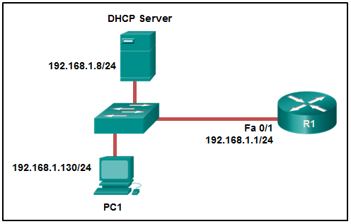

- 192.168.1.1 | - 192.168.1.8
- 192.168.1.255 | - 255.255.255.255

- Jenis pesan apa yang dikirim oleh DHCP client ketika sewa (lease) alamat IP-nya telah kedaluwarsa?​
- a DHCPDISCOVER broadcast message | - a DHCPREQUEST broadcast message​
- a DHCPREQUEST unicast message​ | - a DHCPDISCOVER unicast message​

- Manakah pernyataan yang benar tentang operasi DHCP?​
- If the client receives several DHCPOFFER messages from different servers, it sends a unicast DHCPREQUEST message to the server from which it chooses to obtain the IP information.
- A client must wait for lease expiration before it sends another DHCPREQUEST message.​
- When a device that is configured to use DHCP boots, the client broadcasts a DHCPDISCOVER message to identify any available DHCP servers on the network.​
- The DHCPDISCOVER message contains the IP address and subnet mask to be assigned, the IP address of the DNS server, and the IP address of the default gateway.​

- Apa hasil dari konfigurasi teknisi jaringan yang mengeluarkan perintah ip dhcpexclude-address 10.0.15.1 10.0.15.15 pada router Cisco?
- The Cisco router will exclude 15 IP addresses from being leased to DHCP clients.
- The Cisco router will allow only the specified IP addresses to be leased to clients.
- The Cisco router will exclude only the 10.0.15.1 and 10.0.15.15 IP addresses from being leased to DHCP clients.
- The Cisco router will automatically create a DHCP pool using a /28 mask.

- Komponen AAA mana yang memungkinkan administrator melacak individu yang mengakses sumber daya jaringan dan perubahan apa pun yang dilakukan pada sumber daya tersebut?
a. accessibility | b. accounting
c. authentication | d. authorization

- Lihat gambar. Antarmuka Fa0/2 pada SWITCH S1 telah dikonfigurasi dengan perintah port-security mac-address 0023.189d.6456 dan sebuah workstation telah terhubung. Apa yang menyebabkan antarmuka Fa0/2 menjadi “mati”?
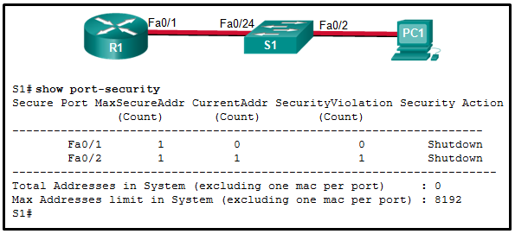

- The connection between S1 and PC1 is via a crossover cable.
- The Fa0/24 interface of S1 is configured with the same MAC address as the Fa0/2 interface.
- S1 has been configured with a switchport port-security aging command.
- The MAC address of PC1 that connects to the Fa0/2 interface is not the configured MAC address.

- Seorang administrator jaringan memasukkan perintah berikut pada sakelar SW1.
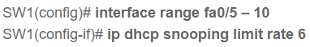

Apa efeknya setelah perintah ini dimasukkan?

- FastEthernet ports 5 through 10 can receive up to 6 DHCP discovery messages per second.
- FastEthernet ports 5 through 10 can receive up to 6 DHCP messages per second of any type.
- If any of the FastEthernet ports 5 through 10 receive more than 6 DHCP messages per second, the port will be shut down.
- If any of the FastEthernet ports 5 through 10 receive more than 6 DHCP messages per second, the port will continue to operate and an error message will be sent to the network administrator.

- Sebutkan dua keuntungan dari static routing dibandingkan dengan dynamic routing?
- Static routing is more secure because it does not advertise over the network.
- Static routing scales well with expanding networks.
- Static routing requires very little knowledge of the network for correct implementation.
- Static routing uses fewer router resources than dynamic routing.
- Static routing is relatively easy to configure for large networks.

- Rute mana yang akan digunakan untuk meneruskan paket dengan alamat IP sumber 192.168.10.1 dan alamat IP tujuan 10.1.1.1?
- C 192.168.10.0/30 is directly connected, GigabitEthernet0/1 | - S 10.1.0.0/16 is directly connected, GigabitEthernet0/0
- O 10.1.1.0/24 [110/65] via 192.168.200.2, 00:01:20, Serial0/1/0 | - S* 0.0.0.0/0 [1/0] via 172.16.1.1

- Lihat gambar. Berapa nilai administrative distance dari rute router R1 untuk mencapai alamat IPv6 tujuan 2001:DB8:CAFE:4::A?
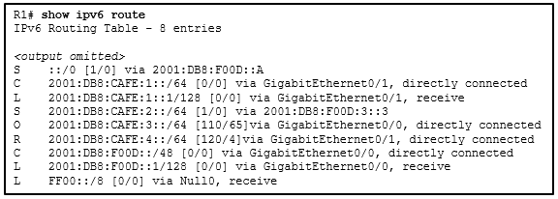

- 1 | - 4 | - 110 | - 120

- Sifat apakah yang melengkapi pernyataan berikut?
Ketika route statis IPv6 dikonfigurasi, penginstalan route dapat diverifikasi dengan ......
- the "show ipv6 route static" command. | - a destination host route with a /128 prefix.
- an administrative distance of 2. | - the interface type and interface number.

- Lihat gambar. Administrator ingin mengaktifkan keamanan port pada antarmuka di SWITCH S1, tetapi perintah itu ditolak. Kesimpulan mana yang bisa ditarik?​
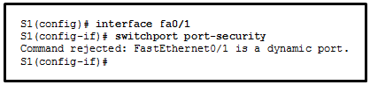

- The interface must be initially configured with the switchport mode trunk command.​
- The interface needs to be configured initially with an IP address.
- The interface must be initially configured with the switchport mode access command.​
- The interface needs to be previously configured with the no shutdown command.​

- Lihat gambar. Perusahaan kecil yang ditampilkan menggunakan perutean statis. Pengguna di LAN R2 telah melaporkan masalah dengan konektivitas. Apa masalahnya?
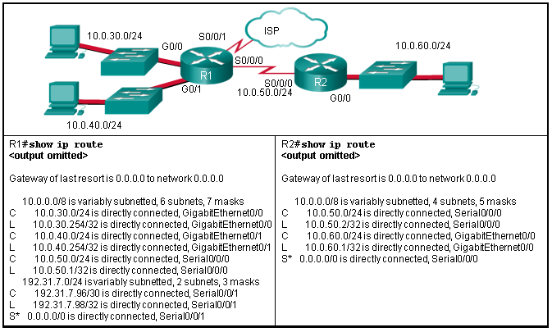
- R2 needs a static route to the R1 LANs. | - R1 needs a default route to R2.
- R1 needs a static route to the R2 LAN. | - R2 needs a static route to the Internet.
- R1 and R2 must use a dynamic routing protocol.

- Lihat gambar. Perintah route statis mana yang dapat dimasukkan pada R1 untuk meneruskan sebuah paket ke LAN yang terhubung ke R2?
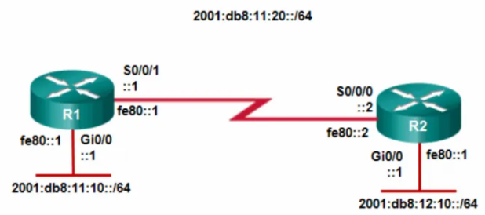

- ipv6 route 2001:db8:12:10::/64 S0/0/0
- ipv6 route 2001:db8:12:10::/64 S0/0/1 fe80::2
- ipv6 route 2001:db8:12:10::/64 S0/0/0 fe80::2
- ipv6 route 2001:db8:12:10::/64 S0/0/1 2001:db8:12:10::1

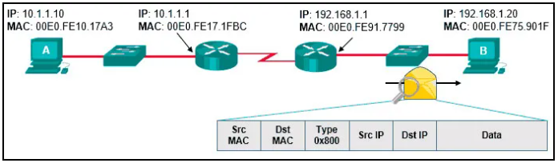
- Lihat gambar. Host A telah mengirimkan paket ke host B. Apa yang akan menjadi sumber MAC dan alamat IP pada paket ketika tiba di host B?

- Source MAC: 00E0.FE10.17A3  Source IP: 10.1.1.10 | - Source MAC: 00E0.FE91.7799  Source IP: 10.1.1.10
- Source MAC: 00E0.FE10.17A3  Source IP: 192.168.1.1 | - Source MAC: 00E0.FE91.7799  Source IP: 192.168.1.1

- Lihat gambar. Semua SWITCH yang ditampilkan adalah Switch Cisco 2960 dengan prioritas default yang sama dan beroperasi pada bandwidth yang sama. Tiga port mana yang akan menjadi STP designated ports?

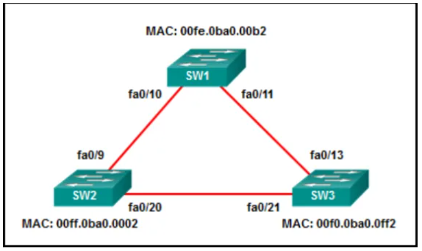

- Fa0/9 | - Fa0/13 | - Fa0/10
- Fa0/20 | - Fa0/21 | - Fa0/11

